INTERNAL TABLE WITH HEADER, WITHOUT HEADER, APPEND LINES OF .. TO .., TRANSPORTING, MODIFY, DELETE, DELETE ADJACENT, sorted by, initial, standard table, collect, at first .. endat, at last .. endat, format color .., format off, sort by, at new .. endat, at end of .. endat, sum, on change of .. endon

REPORT zyny_demo_int_table_01.  
  
*** ITAB declaration  
*data: it_int TYPE TABLE OF i.  
DATA: it_int TYPE STANDARD TABLE OF i, " ITAB declaration without header line  
      wa_int TYPE i. " work area  
  
DATA: it_wint TYPE TABLE OF i WITH HEADER LINE.  
  
*** DATA population into IT_INT using work area WA_INT  
CLEAR : wa_int.  
wa_int = 10.  
APPEND wa_int TO it_int.  
CLEAR : wa_int.  
wa_int = 20.  
APPEND wa_int TO it_int.  
CLEAR : wa_int.  
wa_int = 30.  
APPEND wa_int TO it_int.  
CLEAR : wa_int.  
wa_int = 40.  
APPEND wa_int TO it_int.  
CLEAR : wa_int.  
wa_int = 50.  
APPEND wa_int TO it_int.  
CLEAR : wa_int.  
wa_int = 60.  
APPEND wa_int TO it_int.  
  
**** DATA processing of it_int using work area wa_int  
  
LOOP AT it_int INTO wa_int.  
  WRITE:/ 'wa_int  ', wa_int COLOR 4. " Printing the data line by line  
  WRITE:/ 'sy-tabix', sy-tabix COLOR 5." Current loop pass of IT_INT  
ENDLOOP.  
  
SKIP.  
  
it_wint = 10.  
APPEND it_wint.  
it_wint = 20.  
APPEND it_wint.  
it_wint = 30.  
APPEND it_wint.  
  
LOOP AT it_wint .  
  WRITE:/ 'it_wint ', it_wint COLOR 4. " Printing the data line by line  
  WRITE:/ 'sy-tabix', sy-tabix COLOR 5." Current loop pass of IT_INT  
ENDLOOP.

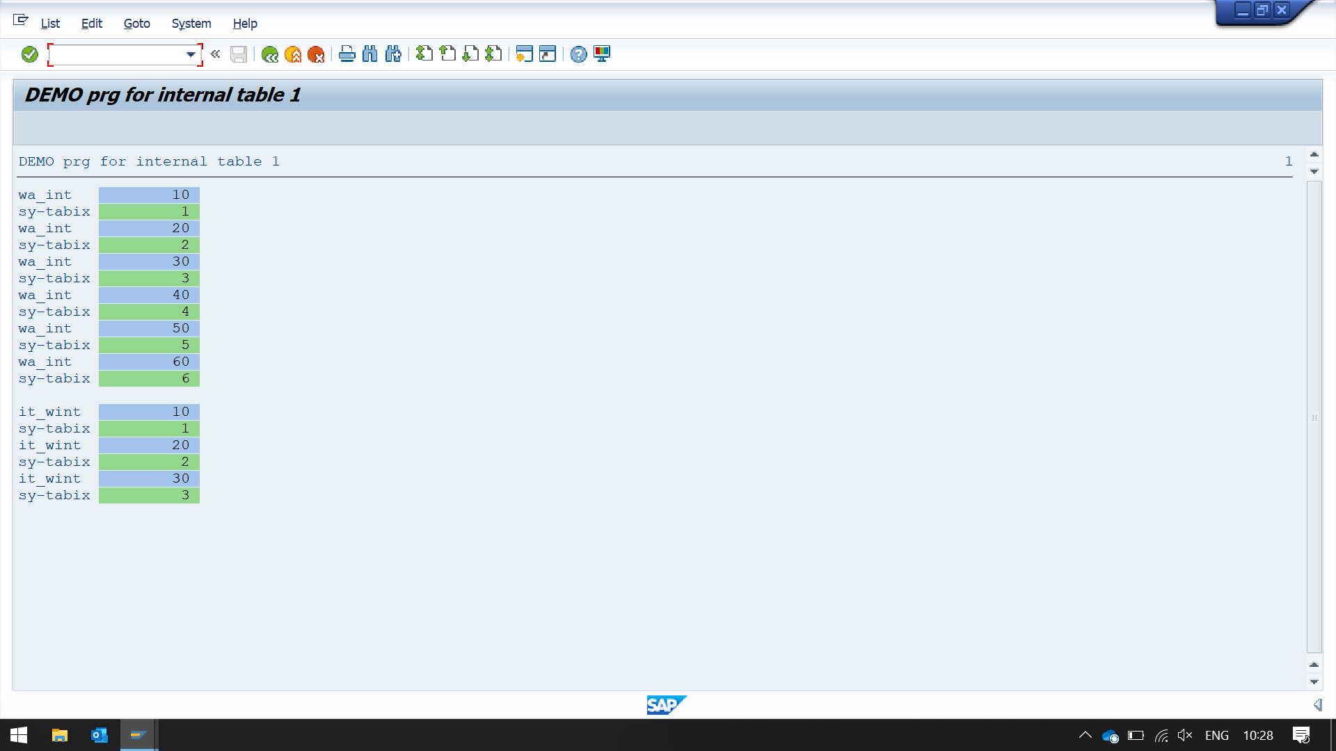

REPORT zyny_demo_int_table_04.  
  
** Local user defined type  
TYPES: BEGIN OF gty_tab,  
         vbeln      TYPE vbak-vbeln,  
         date_crted TYPE erdat,  
         ernam      TYPE vbak-ernam,  
         auart      TYPE vbak-auart,  
         netwr      TYPE vbak-netwr,  
         waerk      TYPE vbak-waerk,  
       END OF gty_tab.  
  
**** Internal table declaration  
DATA: it_so TYPE STANDARD TABLE OF  gty_tab INITIAL SIZE 0, " ITAB  
      wa_so TYPE gty_tab. " Header line or work area  
  
**** Internal table declaration  
DATA: it_so_new TYPE STANDARD TABLE OF  gty_tab INITIAL SIZE 0, " ITAB  
      wa_so_new TYPE gty_tab. " Header line or work area  
  
*START-OF-SELECTION.  
**** DATA population  
CLEAR : wa_so.  
wa_so-vbeln = '1000'.  
wa_so-date_crted = '20220706'.  
wa_so-ernam      = 'TRAINEE01'.  
wa_so-auart    = 'RO'.  
wa_so-netwr    = '1256.55'.  
wa_so-waerk    = 'USD'.  
APPEND wa_so TO it_so.  
  
CLEAR : wa_so.  
wa_so-vbeln = '2000'.  
wa_so-date_crted = '20220606'.  
wa_so-ernam      = 'TRAINEE02'.  
wa_so-auart    = 'SO'.  
wa_so-netwr    = '1856.55'.  
wa_so-waerk    = 'INR'.  
APPEND wa_so TO it_so.  
  
DO 5 TIMES.  
*  CLEAR : wa_so.  
  wa_so-vbeln = wa_so-vbeln + 1 .  
  wa_so-date_crted = wa_so-date_crted + 1.  
  wa_so-ernam      = 'TRAINEE10'.  
  wa_so-auart    = 'SO'.  
  wa_so-netwr    = '1296.55'.  
  wa_so-waerk    = 'EUR'.  
  APPEND wa_so TO it_so.  
ENDDO.  
  
SKIP.  
  
*** data processing  
***** READ INTERNAL TABLE  
CLEAR wa_so.  
READ TABLE it_so INTO wa_so INDEX 5. " reading table with index  
IF sy-subrc = 0.  
  WRITE:/ 'READ table is sucessful sy-tabix', sy-tabix.  
  WRITE:/ wa_so-vbeln, wa_so-date_crted, wa_so-ernam, wa_so-netwr,wa_so-waerk.  
ELSE.  
  WRITE:/ 'READ table is failed '.  
ENDIF.  
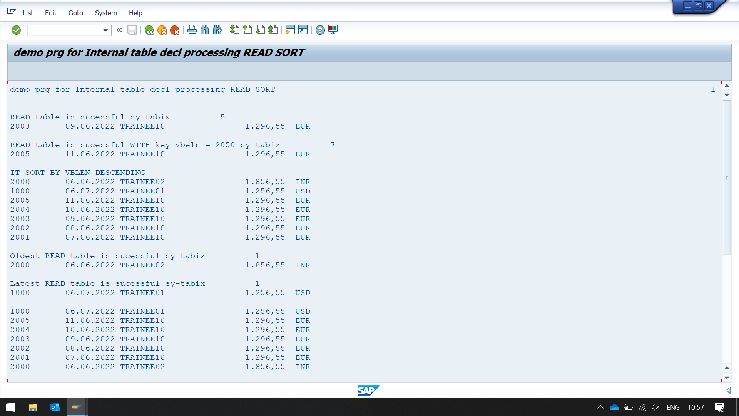  
SKIP.  
  
***** READ INTERNAL TABLE  
CLEAR wa_so.  
*read TABLE it_so INTO wa_so WITH key vbeln = '     2050' .  
READ TABLE it_so INTO wa_so WITH KEY vbeln = 2005 . "reading table with keys  
IF sy-subrc = 0.  
  WRITE:/ 'READ table is sucessful WITH key vbeln = 2050 sy-tabix', sy-tabix.  
  WRITE:/ wa_so-vbeln, wa_so-date_crted, wa_so-ernam, wa_so-netwr,wa_so-waerk.  
ELSE.  
  WRITE:/ 'READ table is failed '.  
ENDIF.  
  
SKIP.  
  
** *********************************************  
*** SORT  
  
SORT it_so BY vbeln DESCENDING. " sorting table in descending order, ascending order by default  
WRITE: / 'IT SORT BY VBLEN DESCENDING'.  
LOOP AT it_so INTO wa_so.  
  IF wa_so-vbeln < 2050.  
    WRITE:/ wa_so-vbeln, wa_so-date_crted, wa_so-ernam, wa_so-netwr,wa_so-waerk.  
  ELSE.  
    WRITE:/ wa_so-vbeln, wa_so-date_crted.  
  ENDIF.  
ENDLOOP.  
  
SKIP.  
  
******  Oldest date  
SORT it_so BY date_crted.  
  
CLEAR wa_so.  
READ TABLE it_so INTO wa_so INDEX 1.  
IF sy-subrc = 0.  
  WRITE:/ 'Oldest READ table is sucessful sy-tabix', sy-tabix.  
  WRITE:/ wa_so-vbeln, wa_so-date_crted, wa_so-ernam, wa_so-netwr,wa_so-waerk.  
ELSE.  
  WRITE:/ 'READ table is failed '.  
ENDIF.  
  
SKIP.  
  
******  Latest date  
SORT it_so BY date_crted DESCENDING.  
  
CLEAR wa_so.  
READ TABLE it_so INTO wa_so INDEX 1.  
IF sy-subrc = 0.  
  WRITE:/ 'Latest READ table is sucessful sy-tabix', sy-tabix.  
  WRITE:/ wa_so-vbeln, wa_so-date_crted, wa_so-ernam, wa_so-netwr,wa_so-waerk.  
ELSE.  
  WRITE:/ 'READ table is failed '.  
ENDIF.  
  
SKIP.  
  
*******************************  
*** APPEND LINE OF  
  
APPEND LINES OF it_so TO it_so_new. " table1 is appended on table2, it is also not sorted by default  
  
APPEND LINES OF it_so TO it_so_new.  
APPEND LINES OF it_so TO it_so_new.  
  
LOOP AT it_so_new INTO wa_so_new.  
  IF wa_so_new-vbeln < 2050.  
    WRITE:/ wa_so_new-vbeln, wa_so_new-date_crted, wa_so_new-ernam, wa_so_new-netwr,wa_so_new-waerk.  
  ELSE.  
    WRITE:/ wa_so_new-vbeln, wa_so_new-date_crted.  
  ENDIF.  
ENDLOOP.  
  
SKIP.

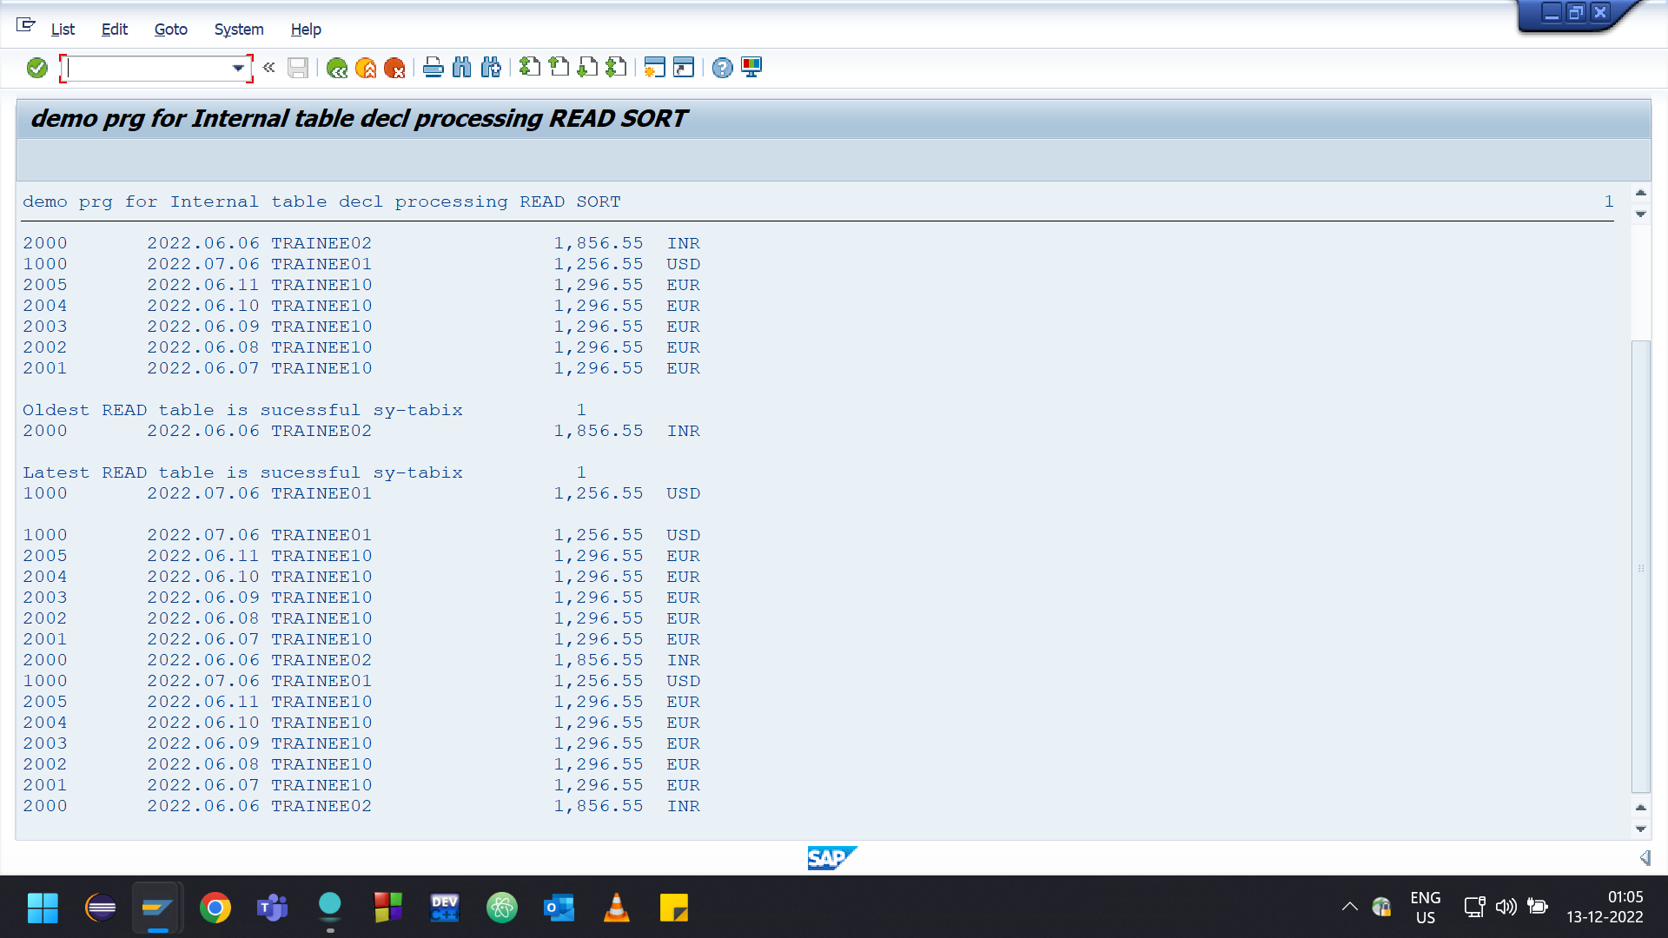

REPORT zyny_demo_int_table_05.  
  
** Local user defined type  
TYPES: BEGIN OF gty_tab,  
         vbeln      TYPE vbak-vbeln,  
         date_crted TYPE erdat,  
         ernam      TYPE vbak-ernam,  
         auart      TYPE vbak-auart,  
         netwr      TYPE vbak-netwr,  
         waerk      TYPE vbak-waerk,  
       END OF gty_tab.  
  
**** Internal table declaration  
DATA: it_so TYPE STANDARD TABLE OF  gty_tab INITIAL SIZE 0, " ITAB  
      wa_so TYPE gty_tab. " Header line or work area  
  
**** Internal table declaration  
DATA: it_so_new TYPE STANDARD TABLE OF  gty_tab INITIAL SIZE 0, " ITAB  
      wa_so_new TYPE gty_tab. " Header line or work area  
  
*START-OF-SELECTION.  
**** DATA population  
CLEAR : wa_so.  
wa_so-vbeln = '1000'.  
wa_so-date_crted = '20220706'.  
wa_so-ernam      = 'TRAINEE01'.  
wa_so-auart    = 'RO'.  
wa_so-netwr    = '156.55'.  
wa_so-waerk    = 'USD'.  
APPEND wa_so TO it_so.  
  
CLEAR : wa_so.  
wa_so-vbeln = '2000'.  
wa_so-date_crted = '20220606'.  
wa_so-ernam      = 'TRAINEE02'.  
wa_so-auart    = 'SO'.  
wa_so-netwr    = '1856.55'.  
wa_so-waerk    = 'INR'.  
APPEND wa_so TO it_so.  
  
DO 5 TIMES.  
  wa_so-vbeln = wa_so-vbeln + 1 .  
  wa_so-date_crted = wa_so-date_crted + 1.  
  wa_so-ernam      = 'TRAINEE10'.  
  wa_so-auart    = 'SO'.  
  wa_so-netwr    = '1296.55'.  
  wa_so-waerk    = 'EUR'.  
  APPEND wa_so TO it_so.  
ENDDO.  
  
*** data processing  
WRITE:/ 'Before ERNAM data Modifcation'.  
LOOP AT it_so INTO wa_so.  
  IF wa_so-vbeln < 2002.  
    WRITE:/ wa_so-vbeln, wa_so-date_crted, wa_so-ernam, wa_so-netwr,wa_so-waerk.  
  ELSE.  
    WRITE:/ wa_so-vbeln, wa_so-date_crted.  
  ENDIF.  
ENDLOOP.  
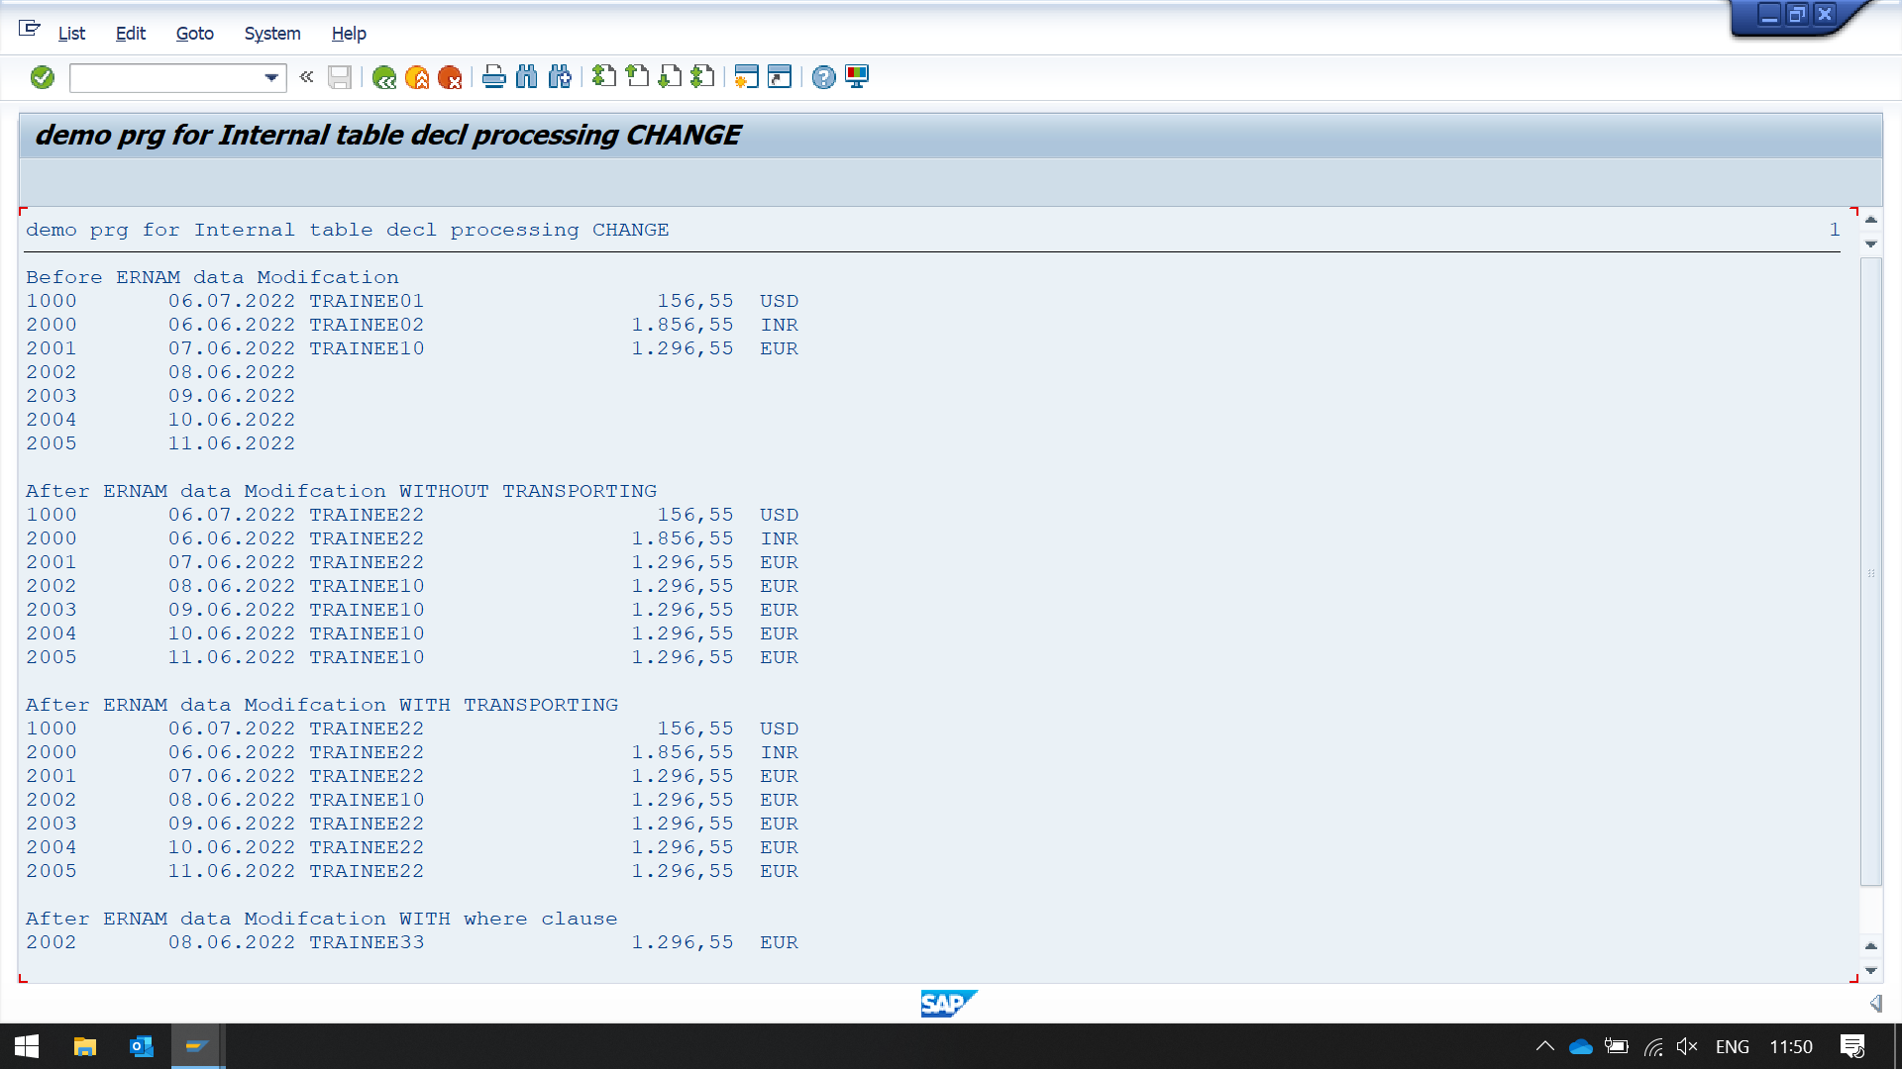  
SKIP.  
  
*** WITHOUT TRANSPORTING  
LOOP AT it_so INTO wa_so.  
  IF wa_so-vbeln < 2002.  
    wa_so-ernam      = 'TRAINEE22'.  
    MODIFY it_so FROM wa_so. " modify internal table from work area  
    clear wa_so.  
  ELSE.  
  ENDIF.  
ENDLOOP.  
  
WRITE:/ 'After ERNAM data Modifcation WITHOUT TRANSPORTING'.  
LOOP AT it_so INTO wa_so.  
  WRITE:/ wa_so-vbeln, wa_so-date_crted, wa_so-ernam, wa_so-netwr,wa_so-waerk.  
ENDLOOP.  
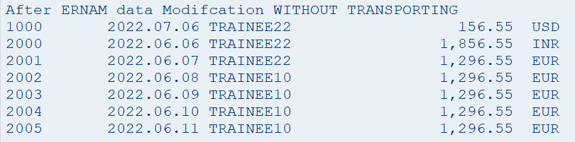  
SKIP.  
  
** DATA CHANGING  
LOOP AT it_so INTO wa_so.  
  IF wa_so-vbeln > 2002.  
    wa_so-ernam      = 'TRAINEE22'.  
    MODIFY it_so FROM wa_so TRANSPORTING ernam. " due to transporting it will only take ernam field from work area The addition TRANSPORTING has the effect that only the specified components [comp1](sapevent:ABENITAB_COMPONENTS), [comp2](sapevent:ABENITAB_COMPONENTS), ... of the work area are assigned to the corresponding components of the row(s) to be changed. For [sorted tables](sapevent:ABENSORTED_TABLE_GLOSRY) and [hashed tables](sapevent:ABENHASHED_TABLE_GLOSRY), no primary table key components may be declared after TRANSPORTING.  
    clear wa_so.  
  ELSE.  
  ENDIF.  
ENDLOOP.  
  
WRITE:/ 'After ERNAM data Modifcation WITH TRANSPORTING'.  
LOOP AT it_so INTO wa_so.  
  WRITE:/ wa_so-vbeln, wa_so-date_crted, wa_so-ernam, wa_so-netwr,wa_so-waerk.  
ENDLOOP.  
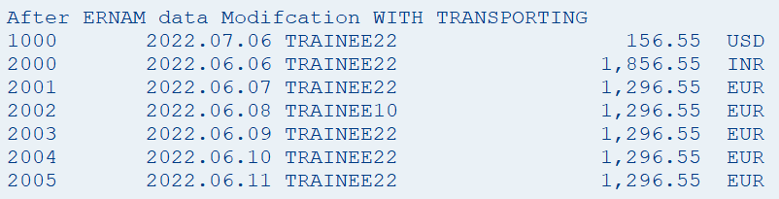  
SKIP.  
  
********************************  
*** MODIFICATION USING WHERE  
wa_so-ernam      = 'TRAINEE33'.  
MODIFY it_so FROM wa_so TRANSPORTING ernam WHERE vbeln = 2002. " transporting statement condition with where condition  
IF sy-subrc = 0.  
  CLEAR wa_so.  
  READ TABLE it_so INTO wa_so WITH KEY vbeln = 2002.  
  IF sy-subrc = 0.  
    WRITE:/ 'After ERNAM data Modifcation WITH where clause'.  
    WRITE:/ wa_so-vbeln, wa_so-date_crted, wa_so-ernam, wa_so-netwr,wa_so-waerk.  
  ENDIF.  
ELSE.  
  WRITE:/'FAILED', 'MODIFY it_so FROM wa_so TRANSPORTING ernam WHERE vbeln = ''2002"'.  
ENDIF.  
  
SKIP.  
  
********************************  
*** MODIFICATION USING index  
wa_so-ernam      = 'TRAINEE44'.  
MODIFY it_so FROM wa_so INDEX 5 TRANSPORTING ernam. " modify statement with index and transporting  
IF sy-subrc = 0.  
  CLEAR wa_so.  
  READ TABLE it_so INTO wa_so INDEX 5.  
  IF sy-subrc = 0.  
    WRITE:/ 'After ERNAM data Modifcation WITH index'.  
    WRITE:/ wa_so-vbeln, wa_so-date_crted, wa_so-ernam, wa_so-netwr,wa_so-waerk.  
  ENDIF.  
ELSE.  
  WRITE:/'FAILED', 'MODIFY it_so FROM wa_so TRANSPORTING ernam index = ''102"'.  
ENDIF.  
  
SKIP.

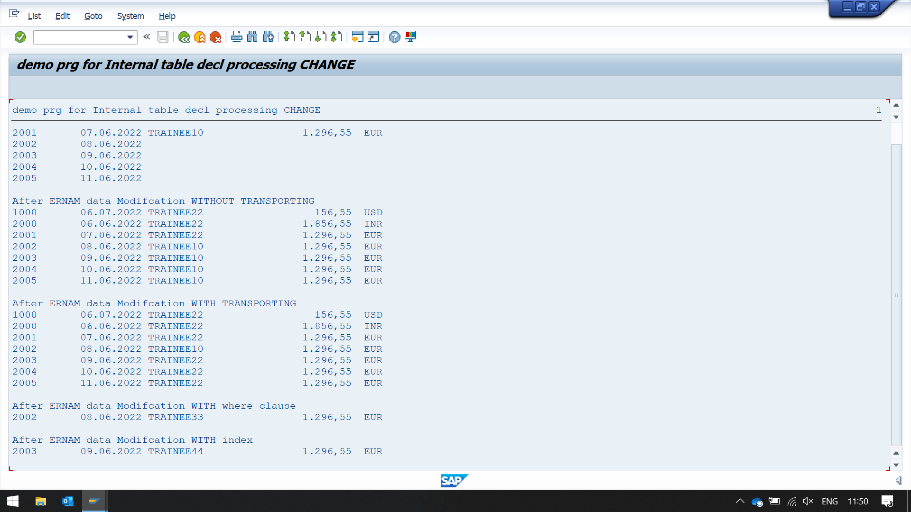

REPORT ZYNY_DEMO_INT_TABLE_06.  
  
** Local user defined type  
TYPES: BEGIN OF GTY_TAB,  
         VBELN      TYPE VBAK-VBELN,  
         DATE_CRTED TYPE ERDAT,  
         ERNAM      TYPE VBAK-ERNAM,  
         AUART      TYPE VBAK-AUART,  
         NETWR      TYPE VBAK-NETWR,  
         WAERK      TYPE VBAK-WAERK,  
       END OF GTY_TAB.  
  
**** Internal table declaration  
DATA: IT_SO     TYPE STANDARD TABLE OF  GTY_TAB INITIAL SIZE 0, " ITAB  
      WA_SO     TYPE GTY_TAB, " Header line or work area  
      IT_SO_NEW TYPE STANDARD TABLE OF  GTY_TAB INITIAL SIZE 0, " ITAB  
      WA_SO_NEW TYPE GTY_TAB. " Header line or work area  
  
*START-OF-SELECTION.  
**** DATA population  
CLEAR : WA_SO.  
WA_SO-VBELN = '1000'.  
WA_SO-DATE_CRTED = '20220706'.  
WA_SO-ERNAM      = 'TRAINEE01'.  
WA_SO-AUART    = 'RO'.  
WA_SO-NETWR    = '126.55'.  
WA_SO-WAERK    = 'USD'.  
APPEND WA_SO TO IT_SO.  
  
CLEAR : WA_SO.  
WA_SO-VBELN = '2000'.  
WA_SO-DATE_CRTED = '20220606'.  
WA_SO-ERNAM      = 'TRAINEE02'.  
WA_SO-AUART    = 'SO'.  
WA_SO-NETWR    = '1856.55'.  
WA_SO-WAERK    = 'INR'.  
APPEND WA_SO TO IT_SO.  
  
DO 5 TIMES.  
  WA_SO-VBELN = WA_SO-VBELN + 1 .  
  WA_SO-DATE_CRTED = WA_SO-DATE_CRTED + 1.  
  WA_SO-ERNAM      = 'TRAINEE10'.  
  WA_SO-AUART    = 'SO'.  
  WA_SO-NETWR    = '1296.55'.  
  WA_SO-WAERK    = 'EUR'.  
  APPEND WA_SO TO IT_SO.  
ENDDO.  
  
*** data processing  
WRITE:/ 'Before data DELETE'.  
LOOP AT IT_SO INTO WA_SO.  
  IF WA_SO-VBELN < 2002.  
    WRITE:/ WA_SO-VBELN, WA_SO-DATE_CRTED, WA_SO-ERNAM, WA_SO-NETWR,WA_SO-WAERK.  
  ELSE.  
    WRITE:/ WA_SO-VBELN, WA_SO-DATE_CRTED.  
  ENDIF.  
ENDLOOP.  
SKIP.  
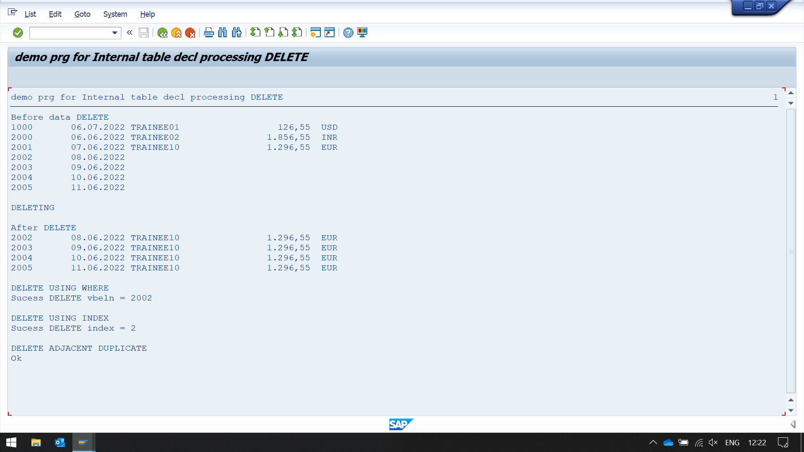  
WRITE : / 'DELETING'.  
  
*** DATA DELETE  
LOOP AT IT_SO INTO WA_SO.  
  IF WA_SO-VBELN < 2002.  
    DELETE IT_SO . " delete the first record from the table  
  ELSE.  
  ENDIF.  
ENDLOOP.  
  
SKIP.  
WRITE:/ 'After DELETE'.  
LOOP AT IT_SO INTO WA_SO.  
  WRITE:/ WA_SO-VBELN, WA_SO-DATE_CRTED, WA_SO-ERNAM, WA_SO-NETWR,WA_SO-WAERK.  
ENDLOOP.  
  
  
*********************************  
**** DELETE USING WHERE  
SKIP.  
WRITE : / 'DELETE USING WHERE'.  
DELETE IT_SO WHERE VBELN = 2002. " delete command with condition  
IF SY-SUBRC <> 0.  
  CLEAR WA_SO.  
  READ TABLE IT_SO INTO WA_SO WITH KEY VBELN = 2002.  
  IF SY-SUBRC = 0.  
    WRITE:/ 'FAILED, After DELETE'.  
    WRITE:/ WA_SO-VBELN, WA_SO-DATE_CRTED, WA_SO-ERNAM, WA_SO-NETWR,WA_SO-WAERK.  
  ENDIF.  
ELSE.  
  WRITE:/'Sucess', 'DELETE vbeln = 2002'.  
ENDIF.  
  
*********************************  
**** DELETE USING index  
SKIP.  
WRITE : / 'DELETE USING INDEX'.  
DELETE IT_SO INDEX 2 ." use 12 as index to check SY-SUBRC = 4 " delete with index  
IF SY-SUBRC <> 0.  
  CLEAR WA_SO.  
  READ TABLE IT_SO INTO WA_SO INDEX 2.  
  IF SY-SUBRC = 0.  
    WRITE:/ 'FAILED DELETE WITH index'.  
    WRITE:/ WA_SO-VBELN, WA_SO-DATE_CRTED, WA_SO-ERNAM, WA_SO-NETWR,WA_SO-WAERK.  
  ENDIF.  
ELSE.  
  WRITE:/'Sucess', 'DELETE index = 2'.  
ENDIF.  
  
*******************************  
*** deleTE ADJACENT DUPLICATE  
SKIP.  
WRITE : / 'DELETE ADJACENT DUPLICATE'.  
  
APPEND LINES OF IT_SO TO IT_SO_NEW .  
APPEND LINES OF IT_SO TO IT_SO_NEW .  
APPEND LINES OF IT_SO TO IT_SO_NEW .  
APPEND LINES OF IT_SO TO IT_SO_NEW .  
  
SORT  IT_SO_NEW BY VBELN.  
  
WRITE : / 'BEFORE DELETING'.  
LOOP AT IT_SO_NEW INTO WA_SO_NEW.  
    WRITE:/ WA_SO_NEW-VBELN, WA_SO_NEW-DATE_CRTED, WA_SO_NEW-ERNAM, WA_SO_NEW-NETWR,WA_SO_NEW-WAERK.  
ENDLOOP.  
  
DELETE ADJACENT DUPLICATES FROM IT_SO_NEW COMPARING VBELN. " DELETING ADJACENT DUPLICATES  
IF SY-SUBRC = 0.  
  WRITE:/ 'Ok'.  
  WRITE :/ 'AFTER DELETING'.  
  LOOP AT IT_SO_NEW INTO WA_SO_NEW.  
    WRITE:/ WA_SO_NEW-VBELN, WA_SO_NEW-DATE_CRTED, WA_SO_NEW-ERNAM, WA_SO_NEW-NETWR,WA_SO_NEW-WAERK.  
  ENDLOOP.  
ELSE.  
  WRITE:/ 'NOT ok'.  
ENDIF.

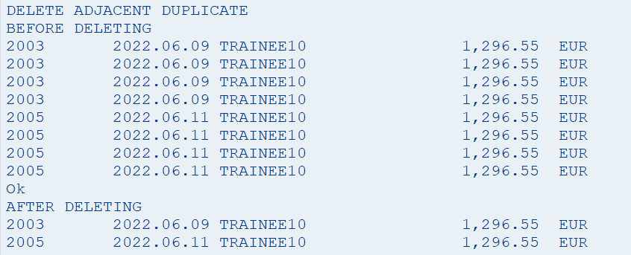

REPORT ZYNY_DEMO_INT_TABLE_07.  
  
** Local user defined type  
TYPES: BEGIN OF GTY_TAB,  
         VBELN      TYPE VBAK-VBELN,  
         DATE_CRTED TYPE ERDAT,  
         ERNAM      TYPE VBAK-ERNAM,  
         AUART      TYPE VBAK-AUART,  
         NETWR      TYPE VBAK-NETWR,  
         WAERK      TYPE VBAK-WAERK,  
       END OF GTY_TAB.  
  
**** Internal table declaration  
*SORTED BY IS NOT WORKING ON IT WITHOUT INTIAL SIZE

Used correctly, this addition can produce ranking lists in descending order. This only works if a value greater than 0 is specified in the declaration of the internal table in the addition [INITIAL SIZE](sapevent:ABAPTYPES_ITAB). If the value 0 is specified for INITIAL SIZE, the statement APPEND has no effect when used with the addition SORTED BY.

read more in documentation of sorted by.

DATA: IT_SO_NEW TYPE STANDARD TABLE OF GTY_TAB, " ITAB  
      IT_SO     TYPE STANDARD TABLE OF GTY_TAB INITIAL SIZE 32, " ITAB  
      WA_SO     TYPE GTY_TAB, " Header line or work area  
      WA_SO_NEW TYPE GTY_TAB, " Header line or work area  
      IT_SO_NEW2 TYPE STANDARD TABLE OF  GTY_TAB INITIAL SIZE 0. " ITAB  
  
*START-OF-SELECTION.  
**** DATA population  
CLEAR : WA_SO.  
CLEAR : WA_SO_NEW.  
WA_SO-VBELN = '1000'.  
WA_SO-DATE_CRTED = '20220706'.  
WA_SO-ERNAM      = 'TRAINEE01'.  
WA_SO-AUART    = 'RO'.  
WA_SO-NETWR    = '100.55'.  
WA_SO-WAERK    = 'USD'.  
MOVE-CORRESPONDING WA_SO TO WA_SO_NEW. " IT WILL MOVE ONLY CORRESPONDING FIELDS (MEANS THE NAME OF FIELDS OF DESTINATION SHOULD BE SAME AS SOURCE)  
APPEND WA_SO TO IT_SO SORTED BY NETWR.  
*WRITE:/ WA_SO-VBELN, WA_SO-DATE_CRTED, WA_SO-ERNAM, WA_SO-NETWR,WA_SO-WAERK.  
*APPEND WA_SO_NEW TO IT_SO_NEW SORTED BY NETWR.  
APPEND WA_SO_NEW TO IT_SO_NEW.  
*LOOP AT IT_SO_NEW INTO WA_SO_NEW.  
*  WRITE:/ WA_SO_NEW-VBELN, WA_SO_NEW-DATE_CRTED, WA_SO_NEW-ERNAM, WA_SO_NEW-NETWR,WA_SO_NEW-WAERK.  
*ENDLOOP.  
*SKIP.  
  
CLEAR : WA_SO.  
CLEAR : WA_SO_NEW.  
WA_SO-VBELN = '2000'.  
WA_SO-DATE_CRTED = '20220606'.  
WA_SO-ERNAM      = 'TRAINEE02'.  
WA_SO-AUART    = 'SO'.  
WA_SO-NETWR    = '1800.55'.  
WA_SO-WAERK    = 'INR'.  
MOVE-CORRESPONDING WA_SO TO WA_SO_NEW.  
*WRITE:/ WA_SO_NEW-VBELN, WA_SO_NEW-DATE_CRTED, WA_SO_NEW-ERNAM, WA_SO_NEW-NETWR,WA_SO_NEW-WAERK.  
APPEND WA_SO TO IT_SO SORTED BY NETWR.  
*WRITE:/ WA_SO-VBELN, WA_SO-DATE_CRTED, WA_SO-ERNAM, WA_SO-NETWR,WA_SO-WAERK.  
APPEND WA_SO_NEW TO IT_SO_NEW.  
*LOOP AT IT_SO_NEW INTO WA_SO_NEW.  
*  WRITE:/ WA_SO_NEW-VBELN, WA_SO_NEW-DATE_CRTED, WA_SO_NEW-ERNAM, WA_SO_NEW-NETWR,WA_SO_NEW-WAERK.  
*ENDLOOP.  
*SKIP.  
  
DO 5 TIMES.  
  WA_SO-VBELN = WA_SO-VBELN + 1 .  
  WA_SO-DATE_CRTED = WA_SO-DATE_CRTED + 1.  
  WA_SO-ERNAM      = 'TRAINEE10'.  
  WA_SO-AUART    = 'SO'.  
  WA_SO-NETWR    = WA_SO-NETWR + 100.  
  WA_SO-WAERK    = 'EUR'.  
  APPEND WA_SO TO IT_SO SORTED BY NETWR.  
  MOVE-CORRESPONDING WA_SO TO WA_SO_NEW.  
*   WRITE:/ WA_SO-VBELN, WA_SO-DATE_CRTED, WA_SO-ERNAM, WA_SO-NETWR,WA_SO-WAERK.  
   APPEND WA_SO_NEW TO IT_SO_NEW.  
ENDDO.  
*LOOP AT IT_SO_NEW INTO WA_SO_NEW.  
*  WRITE:/ WA_SO_NEW-VBELN, WA_SO_NEW-DATE_CRTED, WA_SO_NEW-ERNAM, WA_SO_NEW-NETWR,WA_SO_NEW-WAERK.  
*ENDLOOP.  
*SKIP.  
  
DO 5 TIMES.  
  WA_SO-VBELN = WA_SO-VBELN + 1 .  
  WA_SO-DATE_CRTED = WA_SO-DATE_CRTED + 1.  
  WA_SO-ERNAM      = 'TRAINEE20'.  
  WA_SO-AUART    = 'SO'.  
  WA_SO-NETWR    = WA_SO-NETWR + 100.  
  WA_SO-WAERK    = 'EUR'.  
  MOVE-CORRESPONDING WA_SO TO WA_SO_NEW.  
APPEND WA_SO TO IT_SO SORTED BY NETWR.  
*WRITE:/ WA_SO-VBELN, WA_SO-DATE_CRTED, WA_SO-ERNAM, WA_SO-NETWR,WA_SO-WAERK.  
APPEND WA_SO_NEW TO IT_SO_NEW.  
ENDDO.  
*LOOP AT IT_SO_NEW INTO WA_SO_NEW.  
*  WRITE:/ WA_SO_NEW-VBELN, WA_SO_NEW-DATE_CRTED, WA_SO_NEW-ERNAM, WA_SO_NEW-NETWR,WA_SO_NEW-WAERK.  
*ENDLOOP.  
*SKIP.  
  
DO 5 TIMES.  
  WA_SO-VBELN = WA_SO-VBELN + 1 .  
  WA_SO-DATE_CRTED = WA_SO-DATE_CRTED + 1.  
  WA_SO-ERNAM      = 'TRAINEE30'.  
  WA_SO-AUART    = 'SO'.  
  WA_SO-NETWR    = WA_SO-NETWR + 100.  
  WA_SO-WAERK    = 'EUR'.  
  MOVE-CORRESPONDING WA_SO TO WA_SO_NEW.  
APPEND WA_SO TO IT_SO SORTED BY NETWR.  
*WRITE:/ WA_SO-VBELN, WA_SO-DATE_CRTED, WA_SO-ERNAM, WA_SO-NETWR,WA_SO-WAERK.  
APPEND WA_SO_NEW TO IT_SO_NEW.  
ENDDO.  
*LOOP AT IT_SO_NEW INTO WA_SO_NEW.  
*  WRITE:/ WA_SO_NEW-VBELN, WA_SO_NEW-DATE_CRTED, WA_SO_NEW-ERNAM, WA_SO_NEW-NETWR,WA_SO_NEW-WAERK.  
*ENDLOOP.  
*SKIP.  
  
*** data processing  
SKIP.

if table is initialized with size of 20 then it will only contain 20 records  
WRITE : / 'DUE TO SIZE CONSTRAINT ONLY 20 IS SHOWN HERE , CONSTRAINT IS PLACED IN LINE OF DECLARATION'.  
LOOP AT IT_SO INTO WA_SO.  
  WRITE:/ WA_SO-VBELN, WA_SO-DATE_CRTED, WA_SO-ERNAM, WA_SO-NETWR,WA_SO-WAERK.  
ENDLOOP.  
  
SKIP.  
WRITE: / 'NO CONSTRAINT IT TABLE'.  
LOOP AT IT_SO_NEW INTO WA_SO_NEW.  
  WRITE:/ WA_SO_NEW-VBELN, WA_SO_NEW-DATE_CRTED, WA_SO_NEW-ERNAM, WA_SO_NEW-NETWR,WA_SO_NEW-WAERK.  
ENDLOOP.

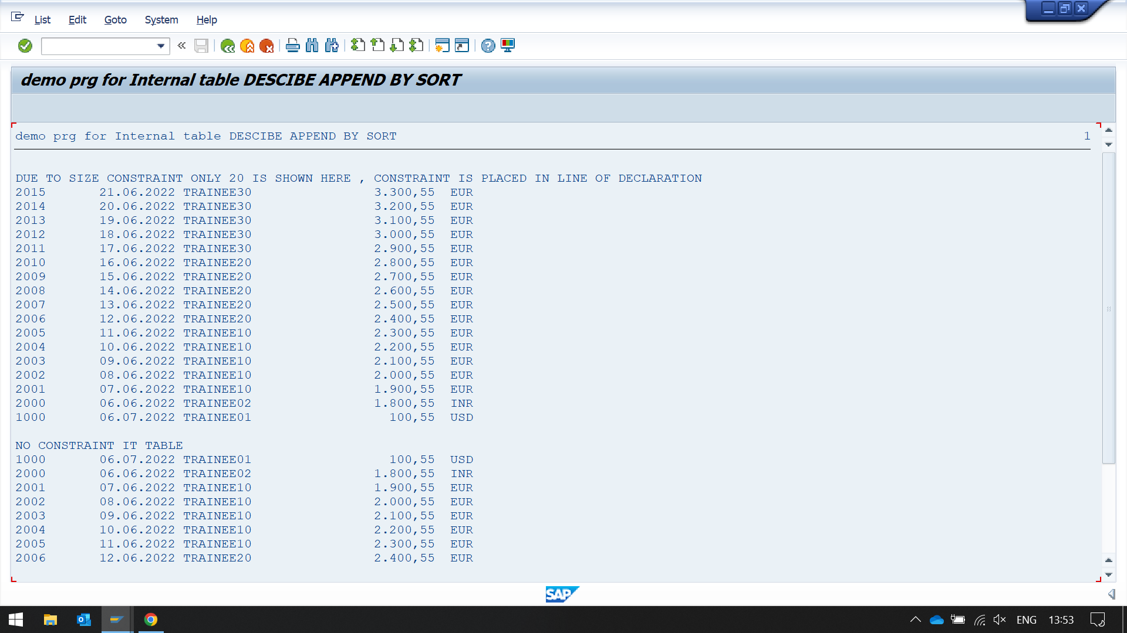

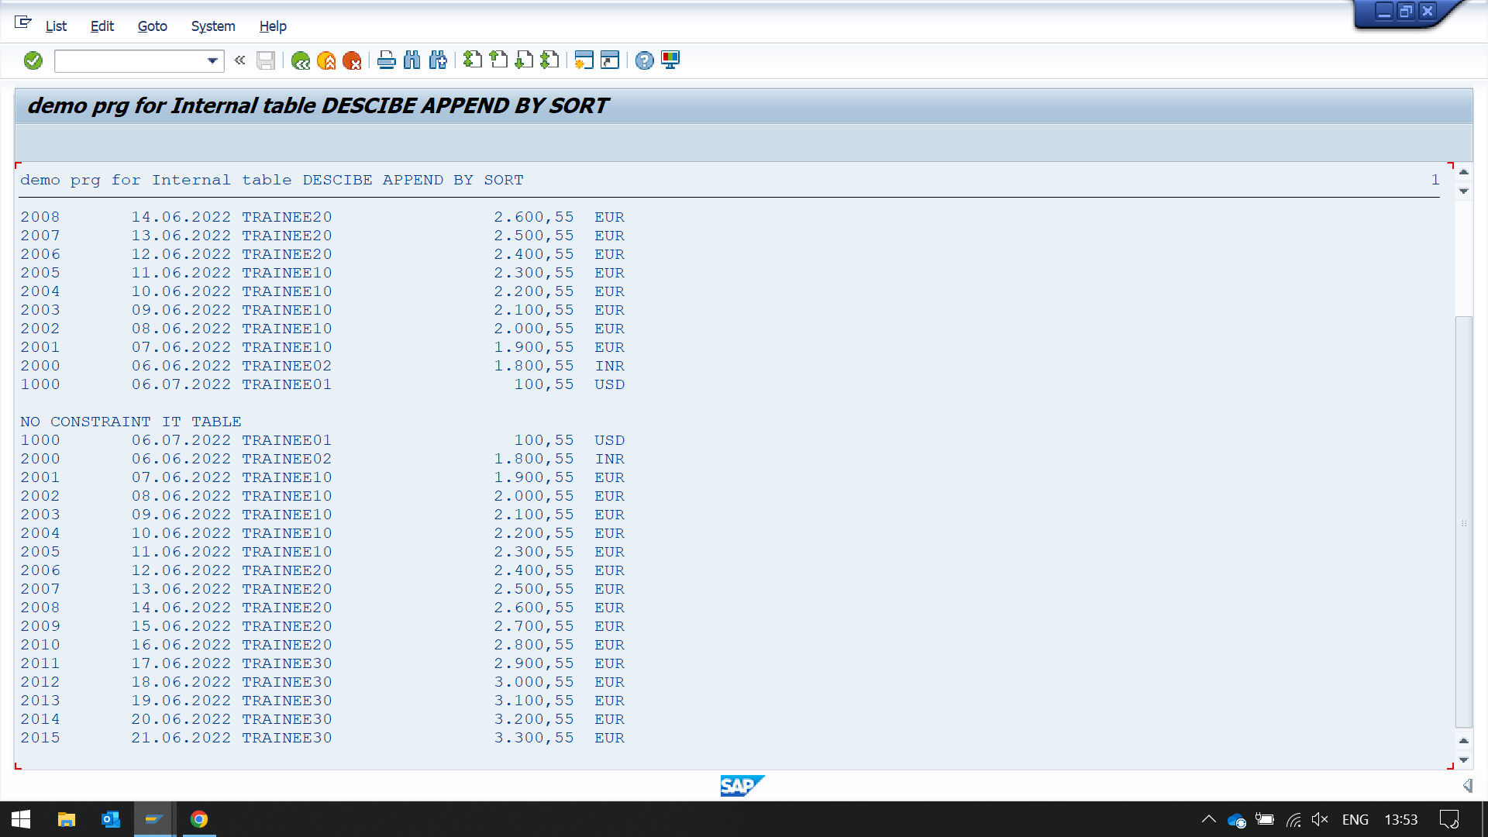

REPORT ZYNY_DEMO_INT_TABLE_08.  
  
TYPES: BEGIN OF ITTYPE ,  
         SALES    TYPE P DECIMALS 2,  
         NAME(10) TYPE C,  
         DATE     TYPE D,  
         num      type i,  
       END OF ITTYPE.  
DATA: IT TYPE STANDARD TABLE OF ITTYPE INITIAL SIZE 0,  
       WA TYPE ITTYPE.  
*This statement inserts the content of a work area wa either as a single row in an internal table itab  
*adds the values of its numeric components to the corresponding values of existing rows with the same  
*primary table key. wa is a functional operand position.  
WA-DATE = '19980101'. WA-SALES = 100. WA-NAME  = 'Jack'. wa-num = 100.  
COLLECT WA INTO IT.  
WA-DATE = '19980101'. WA-SALES = 400. WA-NAME  = 'Jack'. wa-num = 23.  
COLLECT WA INTO IT.  
clear wa.  
 " here sales adds up 100 + 400 = 500 and same with num  
WA-DATE = '19980102'. WA-SALES = 300. WA-NAME  = 'Jack'.  
COLLECT WA INTO IT.  
WA-DATE = '19980102'. WA-SALES = 700. WA-NAME  = 'Jack'.  
COLLECT WA INTO IT.  
 " here we are clearing the work area so 0 + 0 = 0, but sales are still adding 300 + 700 = 1000  
WA-DATE = '19980101'. WA-SALES = 200. WA-NAME  = 'Jim'.  
COLLECT WA INTO IT.  
WA-DATE = '19980101'. WA-SALES = 500. WA-NAME  = 'Jim'.  
COLLECT WA INTO IT.  
  
WA-DATE = '19980101'. WA-SALES = 600. WA-NAME  = 'Jane'.  
COLLECT WA INTO IT.  
WA-DATE = '19980101'. WA-SALES = 600. WA-NAME  = 'Jane'.  
COLLECT WA INTO IT.  
  
WA-DATE = '19980102'. WA-SALES = 600. WA-NAME  = 'Jane'.  
COLLECT WA INTO IT.  
WA-DATE = '19980102'. WA-SALES = 500. WA-NAME  = 'Jane'.  
COLLECT WA INTO IT.  
  
  
LOOP AT IT INTO WA.  
  WRITE: /  WA-DATE, WA-NAME, WA-SALES , wa-num.  
ENDLOOP.

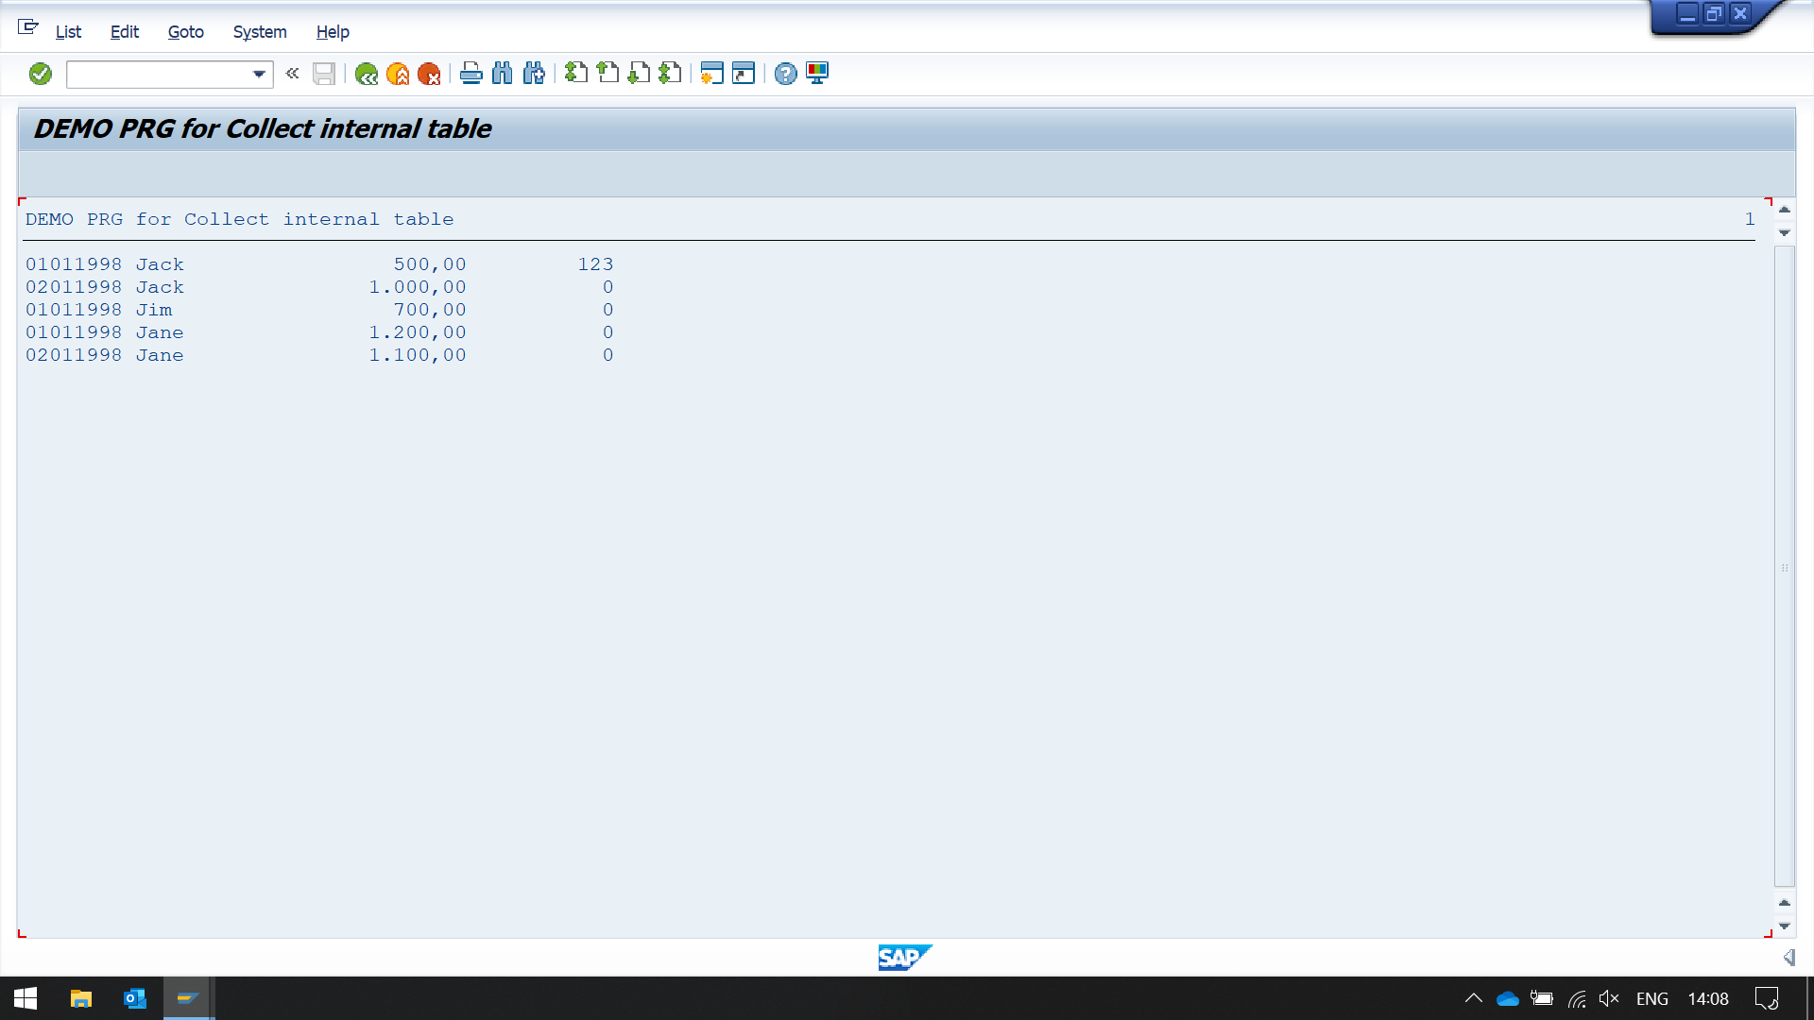

REPORT ZYNY_DEMO_INT_TABLE_09.  
  
TYPES: BEGIN OF FLIGHTTYPE,  
         CARRID    TYPE SFLIGHT-CARRID,  
         CONNID    TYPE SFLIGHT-CONNID,  
         FLDATE    TYPE SFLIGHT-FLDATE,  
         PLANETYPE TYPE SFLIGHT-PLANETYPE,  
         SEATSMAX  TYPE SFLIGHT-SEATSMAX,  
         SEATSOCC  TYPE SFLIGHT-SEATSOCC,  
       END OF   FLIGHTTYPE.  
DATA: ITSFLIGHT TYPE STANDARD TABLE OF FLIGHTTYPE INITIAL SIZE 0,  
      WA        TYPE  FLIGHTTYPE.  
  
SELECT CARRID CONNID FLDATE PLANETYPE SEATSMAX SEATSOCC UP TO 4 ROWS  
    FROM SFLIGHT  
  INTO TABLE ITSFLIGHT.  
  
LOOP AT ITSFLIGHT INTO WA.  
  AT FIRST.  
    FORMAT COLOR 5. " coloring the result  
    WRITE: /  'Carrid',  
            12 'Connid',  
            25 'Flightdate',  
            45 'Plane Type',  
            65 'Seats Maximum',  
            85 'Seats Occupied'.  
    FORMAT COLOR OFF.  
    ULINE.  
  ENDAT.  
  WRITE : / WA-CARRID ,  
           12 WA-CONNID,  
           25 WA-FLDATE,  
           45 WA-PLANETYPE,  
           65 WA-SEATSMAX,  
           85 WA-SEATSOCC.  
  AT LAST.  
    write : / sy-uline.  
    WRITE: /  '--------',  
           12 '------',  
           25 '----------',  
           45 '---------',  
           70 '-----',  
           90 '-----'.  
  ENDAT.  
ENDLOOP.

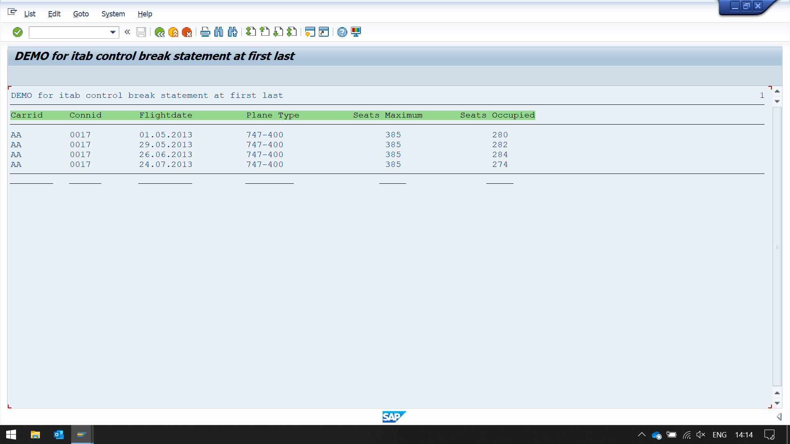REPORT zyny_demo_int_table_10.  
  
TYPES: BEGIN OF flighttype,  
         carrid    TYPE sflight-carrid,  
         connid    TYPE sflight-connid,  
         fldate    TYPE sflight-fldate,  
         planetype TYPE sflight-planetype,  
         seatsmax  TYPE sflight-seatsmax,  
         seatsocc  TYPE sflight-seatsocc,  
       END OF   flighttype.  
DATA: itsflight TYPE STANDARD TABLE OF flighttype       INITIAL SIZE 0,  
      wa        TYPE  flighttype.  
  
data: wa_new        TYPE  flighttype.  
data: gv_flag TYPE c.  
  
wa-carrid = 'AA'. wa-connid = '17'. wa-fldate = '20190731'. wa-planetype = '747-400'.  wa-seatsmax = 385. wa-seatsocc = 375.  
APPEND wa TO itsflight.  
  
wa-carrid = 'AZ'. wa-connid = '64'. wa-fldate = '20190827'. wa-planetype = 'DC-10-10'. wa-seatsmax = 380. wa-seatsocc = 367.  
APPEND wa TO itsflight.  
  
wa-carrid = 'DL'. wa-connid = '17'. wa-fldate = '20190923'. wa-planetype = 'A310-300'. wa-seatsmax = 280. wa-seatsocc = 271.  
APPEND wa TO itsflight.  
  
wa-carrid = 'AZ'. wa-connid = '64'. wa-fldate = '20190731'. wa-planetype = 'A319'.     wa-seatsmax = 220. wa-seatsocc = 211.  
APPEND wa TO itsflight.  
  
wa-carrid = 'AA'. wa-connid = '17'. wa-fldate = '20190830'. wa-planetype = 'A310-300'. wa-seatsmax = 280. wa-seatsocc = 261.  
APPEND wa TO itsflight.  
  
wa-carrid = 'DL'. wa-connid = '64'. wa-fldate = '20190923'. wa-planetype = 'A319'.     wa-seatsmax = 220. wa-seatsocc = 213.  
APPEND wa TO itsflight.  
  
wa-carrid = 'AA'. wa-connid = '64'. wa-fldate = '20190828'. wa-planetype = '747-400'.  wa-seatsmax = 385. wa-seatsocc = 371.  
APPEND wa TO itsflight.  
  
wa-carrid = 'AZ'. wa-connid = '17'. wa-fldate = '20190828'. wa-planetype = 'A319'.     wa-seatsmax = 220. wa-seatsocc = 205.  
APPEND wa TO itsflight.  
  
wa-carrid = 'AA'. wa-connid = '64'. wa-fldate = '20190802'. wa-planetype = 'A310-300'. wa-seatsmax = 280. wa-seatsocc = 271.  
APPEND wa TO itsflight.  
  
wa-carrid = 'AZ'. wa-connid = '17'. wa-fldate = '20190924'. wa-planetype = 'DC-10-10'. wa-seatsmax = 380. wa-seatsocc = 370.  
APPEND wa TO itsflight.  
  
wa-carrid = 'DL'. wa-connid = '17'. wa-fldate = '20190826'. wa-planetype = 'A310-300'. wa-seatsmax = 280. wa-seatsocc = 270.  
APPEND wa TO itsflight.  
  
wa-carrid = 'AZ'. wa-connid = '64'. wa-fldate = '20190802'. wa-planetype = 'DC-10-10'. wa-seatsmax = 380. wa-seatsocc = 361.  
APPEND wa TO itsflight.  
  
wa-carrid = 'DL'. wa-connid = '64'. wa-fldate = '20190826'. wa-planetype = 'A319'.     wa-seatsmax = 220. wa-seatsocc = 213.  
APPEND wa TO itsflight.  
  
wa-carrid = 'AZ'. wa-connid = '64'. wa-fldate = '20190828'. wa-planetype = 'A310-300'. wa-seatsmax = 380. wa-seatsocc = 361.  
APPEND wa TO itsflight.  
  
  
SORT itsflight BY carrid.  
LOOP AT  itsflight  INTO wa.  
  AT FIRST. " at first iteration of loop  
    PERFORM dispfirst.  
  ENDAT.  
  PERFORM dispallfields.  
  AT LAST. " at last iteration of loop  
    PERFORM displast.  
  ENDAT.  
ENDLOOP.  
  
SKIP 2.  
LOOP AT  itsflight  INTO wa.  
  wa_new = wa.              " Collect the data in new work area  
  clear gv_flag.  
  AT NEW carrid. " at every new value of carrid  
    gv_flag = 'X'.  
    PERFORM dispallfields.  
  ENDAT.  
  AT END OF carrid. " at last value of wa first field (means every ending of a continuous value)  
    WRITE : / 'End' ,  wa-carrid.  
  ENDAT.  
ENDLOOP.  
SKIP.  
  
FORM dispallfields.  
  WRITE : / wa-carrid ,  
          12 wa-connid,  
          25 wa-fldate,  
          45 wa-planetype,  
          65 wa-seatsmax,  
          85 wa-seatsocc.  
  
if gv_flag = 'X'.  
  WRITE : / 'AT NEW of CARRID'.  
  WRITE : / wa_new-carrid ,  
          12 wa_new-connid,  
          25 wa_new-fldate,  
          45 wa_new-planetype,  
          65 wa_new-seatsmax,  
          85 wa_new-seatsocc.  
 ENDIF.  
ENDFORM.  
  
FORM dispfirst.  
  WRITE: /  'Carrid',  
          12 'Connid',  
          25 'Flightdate',  
          45 'Plane Type',  
          65 'Seats Maximum',  
          85 'Seats Occupied'.  
  ULINE.  
ENDFORM.  
  
  
FORM displast.  
  WRITE: /  '--------',  
            12 '------',  
            25 '----------',  
            45 '---------',  
            65 '---------',  
            85 '---------'.  
ENDFORM.

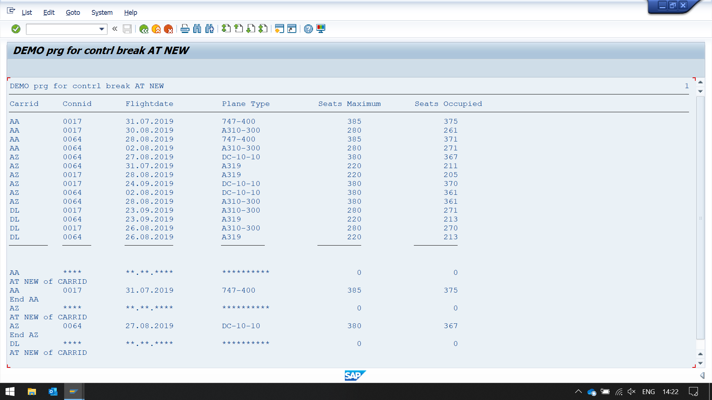

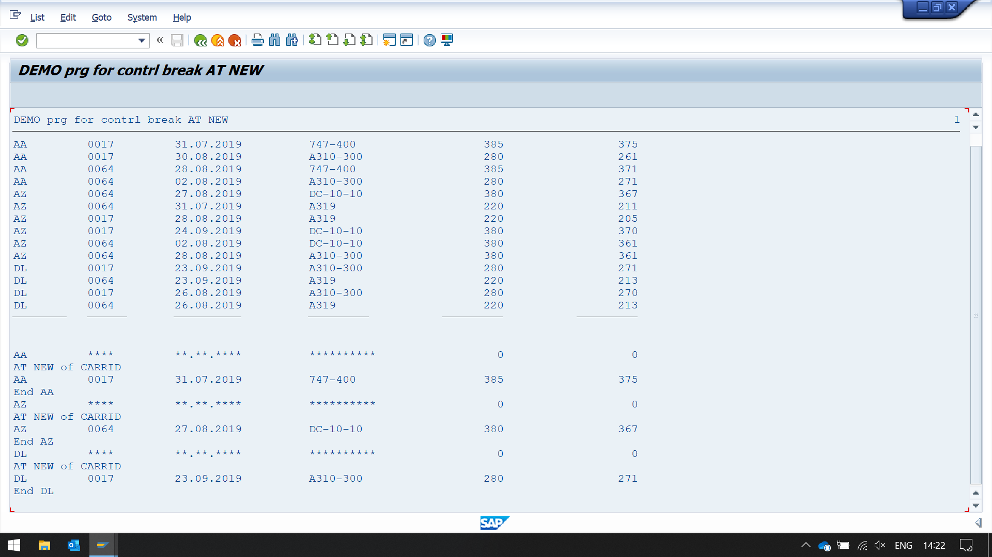REPORT zyny_demo_int_table_11.  
  
TYPES: BEGIN OF flighttype,  
         carrid    TYPE sflight-carrid,  
         connid    TYPE sflight-connid,  
         fldate    TYPE sflight-fldate,  
         planetype TYPE sflight-planetype,  
         seatsmax  TYPE sflight-seatsmax,  
         seatsocc  TYPE sflight-seatsocc,  
       END OF   flighttype.  
  
DATA: itsflight TYPE STANDARD TABLE OF flighttype INITIAL SIZE 0,  
      wa        TYPE  flighttype.  
  
PERFORM selectfromdb.  
  
SORT itsflight BY CARRID.  
LOOP AT  itsflight  INTO wa.  
  AT FIRST.  
    PERFORM dispfirst.  
  ENDAT.  
  AT NEW carrid.  
    WRITE : / 'Carrid:', wa-carrid.  
  ENDAT.  
  
  PERFORM disprestfields.  
  
  AT END OF carrid.  
    SUM. " HERE SUM OF ALL THE FIELDS ARE STORED IN THE WORK AREA  
    ULINE.  
    WRITE : / 'Carrid' ,  wa-carrid , 65 wa-seatsmax, 85 wa-seatsocc.  
    WRITE: /12 wa-connid,  
          25 wa-fldate,  
          45 wa-planetype,  
          65 wa-seatsmax,  
          85 wa-seatsocc.  
    ULINE.  
  ENDAT.  
  AT LAST.  
    PERFORM displast.  
  ENDAT.  
ENDLOOP.  
SKIP.  
  
FORM selectfromdb.  
  SELECT carrid connid fldate planetype seatsmax seatsocc UP TO 50 ROWS  
      FROM sflight  
    INTO TABLE itsflight.  
ENDFORM.  
  
FORM disprestfields.  
  WRITE: /12 wa-connid,  
          25 wa-fldate,  
          45 wa-planetype,  
          65 wa-seatsmax,  
          85 wa-seatsocc.  
ENDFORM.  
  
FORM dispfirst.  
  WRITE: /'Carrid',  
          12 'Connid',  
          25 'Flightdate',  
          45 'Plane Type',  
          65 'Seats Maximum',  
          85 'Seats Occupied'.  
  ULINE.  
ENDFORM.  
  
FORM displast.  
  WRITE: /'--------',  
          12 '------',  
          25 '----------',  
          45 '---------'.  
  uline.  
ENDFORM.

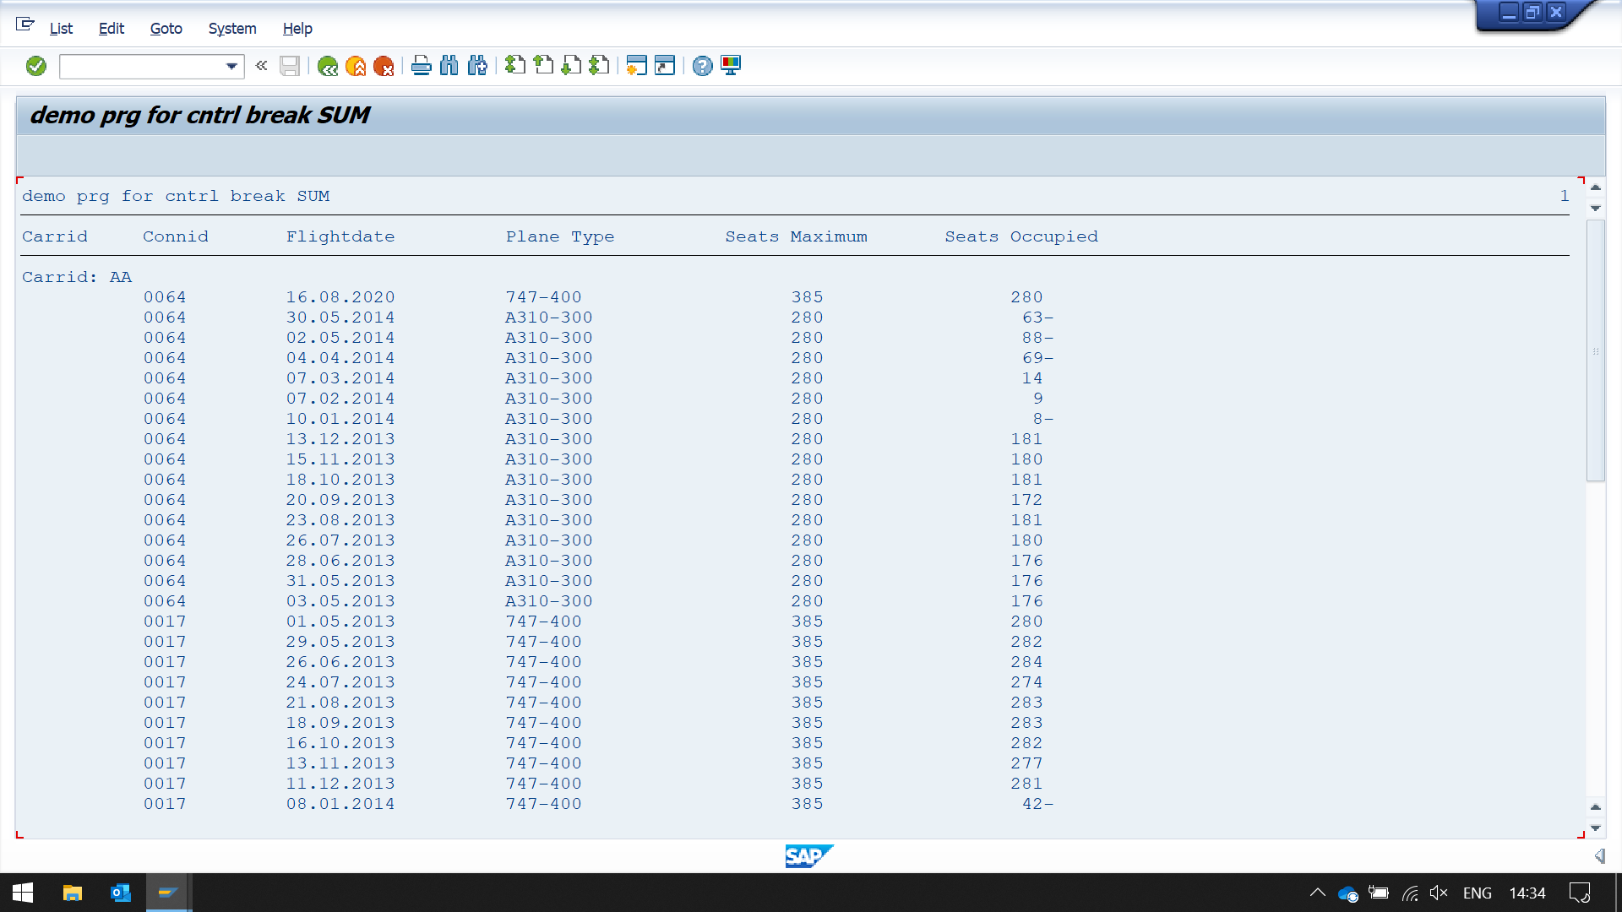

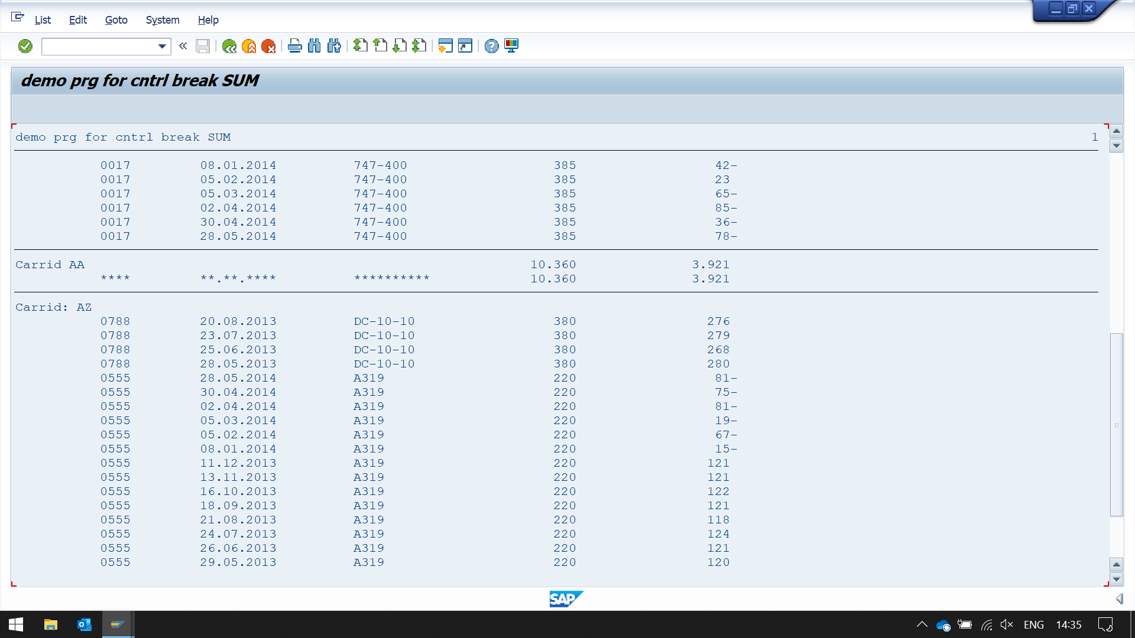

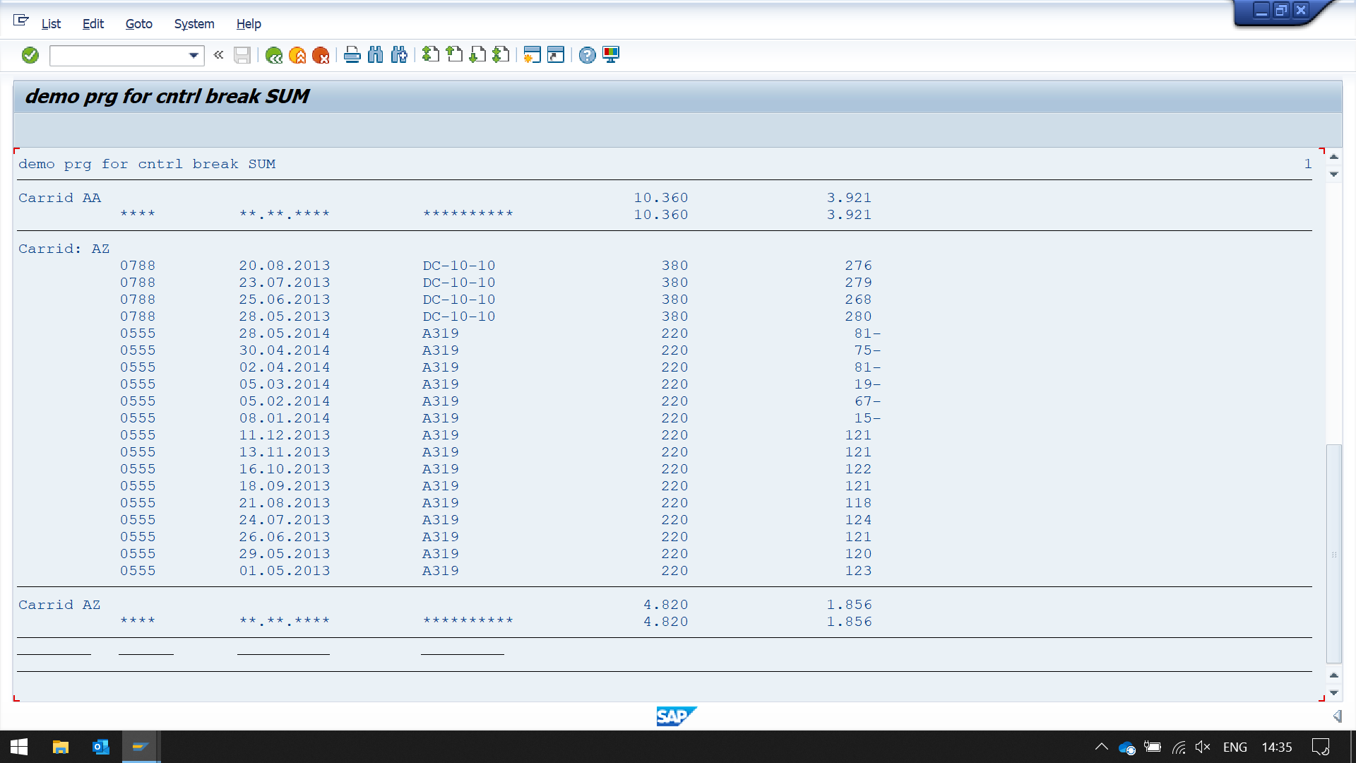

REPORT ZYNY_DEMO_INT_TABLE_12.  
  
TYPES: BEGIN OF FLIGHTTYPE,  
         FLDATE    TYPE SFLIGHT-FLDATE,  
         PLANETYPE TYPE SFLIGHT-PLANETYPE,  
         CARRID    TYPE SFLIGHT-CARRID,  
         CONNID    TYPE SFLIGHT-CONNID,  
         SEATSMAX  TYPE SFLIGHT-SEATSMAX,  
         SEATSOCC  TYPE SFLIGHT-SEATSOCC,  
       END OF   FLIGHTTYPE.  
DATA: ITSFLIGHT TYPE STANDARD TABLE OF FLIGHTTYPE  
      INITIAL SIZE 0,  
      WA        TYPE  FLIGHTTYPE.  
  
WA-CARRID = 'AA'. WA-CONNID = '17'. WA-FLDATE = '20190731'. WA-PLANETYPE = '747-400'. WA-SEATSMAX = 385. WA-SEATSOCC = 375.  
APPEND WA TO ITSFLIGHT.  
  
WA-CARRID = 'AZ'. WA-CONNID = '64'. WA-FLDATE = '20190827'. WA-PLANETYPE = 'DC-10-10'. WA-SEATSMAX = 380. WA-SEATSOCC = 367.  
APPEND WA TO ITSFLIGHT.  
  
WA-CARRID = 'DL'. WA-CONNID = '17'. WA-FLDATE = '20190923'. WA-PLANETYPE = 'A310-300'. WA-SEATSMAX = 280. WA-SEATSOCC = 271.  
APPEND WA TO ITSFLIGHT.  
  
WA-CARRID = 'AZ'. WA-CONNID = '64'. WA-FLDATE = '20190731'. WA-PLANETYPE = 'A319'. WA-SEATSMAX = 220. WA-SEATSOCC = 211.  
APPEND WA TO ITSFLIGHT.  
  
WA-CARRID = 'AA'. WA-CONNID = '17'. WA-FLDATE = '20190830'. WA-PLANETYPE = 'A310-300'. WA-SEATSMAX = 280. WA-SEATSOCC = 261.  
APPEND WA TO ITSFLIGHT.  
  
WA-CARRID = 'DL'. WA-CONNID = '64'. WA-FLDATE = '20190923'. WA-PLANETYPE = 'A319'. WA-SEATSMAX = 220. WA-SEATSOCC = 213.  
APPEND WA TO ITSFLIGHT.  
  
WA-CARRID = 'AA'. WA-CONNID = '64'. WA-FLDATE = '20190828'. WA-PLANETYPE = '747-400'.  WA-SEATSMAX = 385. WA-SEATSOCC = 371.  
APPEND WA TO ITSFLIGHT.  
  
WA-CARRID = 'AZ'. WA-CONNID = '17'. WA-FLDATE = '20190828'. WA-PLANETYPE = 'A319'. WA-SEATSMAX = 220. WA-SEATSOCC = 205.  
APPEND WA TO ITSFLIGHT.  
  
WA-CARRID = 'AA'. WA-CONNID = '64'. WA-FLDATE = '20190802'. WA-PLANETYPE = 'A310-300'. WA-SEATSMAX = 280. WA-SEATSOCC = 271.  
APPEND WA TO ITSFLIGHT.  
  
WA-CARRID = 'AZ'. WA-CONNID = '17'. WA-FLDATE = '20190924'. WA-PLANETYPE = 'DC-10-10'. WA-SEATSMAX = 380. WA-SEATSOCC = 370.  
APPEND WA TO ITSFLIGHT.  
  
WA-CARRID = 'DL'. WA-CONNID = '17'. WA-FLDATE = '20190826'. WA-PLANETYPE = 'A310-300'. WA-SEATSMAX = 280. WA-SEATSOCC = 270.  
APPEND WA TO ITSFLIGHT.  
  
WA-CARRID = 'AZ'. WA-CONNID = '64'. WA-FLDATE = '20190802'. WA-PLANETYPE = 'DC-10-10'. WA-SEATSMAX = 380. WA-SEATSOCC = 361.  
APPEND WA TO ITSFLIGHT.  
  
WA-CARRID = 'DL'. WA-CONNID = '64'. WA-FLDATE = '20190826'. WA-PLANETYPE = 'A319'. WA-SEATSMAX = 220. WA-SEATSOCC = 213.  
APPEND WA TO ITSFLIGHT.  
  
WA-CARRID = 'AZ'. WA-CONNID = '64'. WA-FLDATE = '20190828'. WA-PLANETYPE = 'A310-300'. WA-SEATSMAX = 380. WA-SEATSOCC = 361.  
APPEND WA TO ITSFLIGHT.  
  
  
SORT ITSFLIGHT BY CARRID.  
LOOP AT  ITSFLIGHT  INTO WA.  
  AT FIRST.  
    PERFORM DISPFIRST.  
  ENDAT.  
  PERFORM DISPALLFIELDS.  
  AT LAST.  
    PERFORM DISPLAST.  
  ENDAT.  
ENDLOOP.  
  
SKIP 2.  
LOOP AT  ITSFLIGHT  INTO WA.  
*  here we are displaying content of only that carrid, when it change  
  ON CHANGE OF WA-CARRID.  
    PERFORM DISPALLFIELDS.  
  ENDON.  
ENDLOOP.  
SKIP.  
  
FORM DISPALLFIELDS.  
  WRITE : / WA-CARRID ,  
          12 WA-CONNID,  
          25 WA-FLDATE,  
          45 WA-PLANETYPE,  
          65 WA-SEATSMAX,  
          85 WA-SEATSOCC.  
ENDFORM.  
  
FORM DISPFIRST.  
  WRITE: /  'Carrid',  
          12 'Connid',  
          25 'Flightdate',  
          45 'Plane Type',  
          65 'Seats Maximum',  
          85 'Seats Occupied'.  
  ULINE.  
ENDFORM.  
  
FORM DISPLAST.  
  WRITE: /  '--------',  
            12 '------',  
            25 '----------',  
            45 '---------',  
            65 '---------',  
            85 '---------'.  
ENDFORM.

